Digital Calculator – Internal Components, Working Process & Circuit Diagram

1. Introduction
A digital calculator is an electronic device designed to perform arithmetic operations such as addition, subtraction, multiplication, and division using digital electronic circuits. Internally, it consists of several functional blocks that work together to receive input, process data, and display results.

Calculator internal block diagram
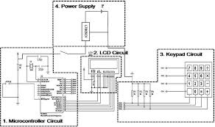CV
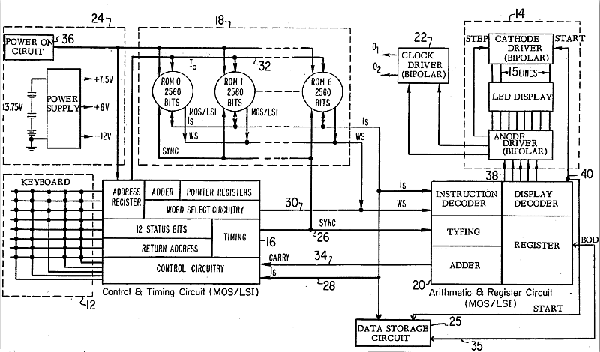+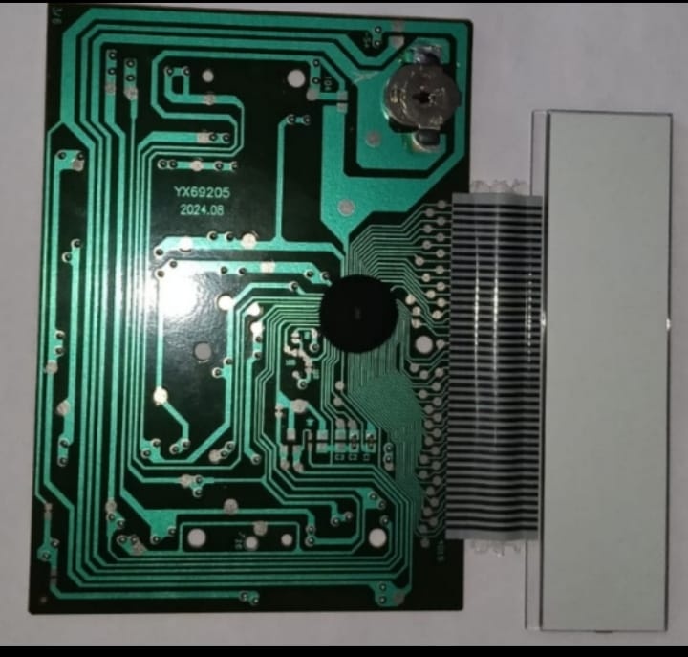 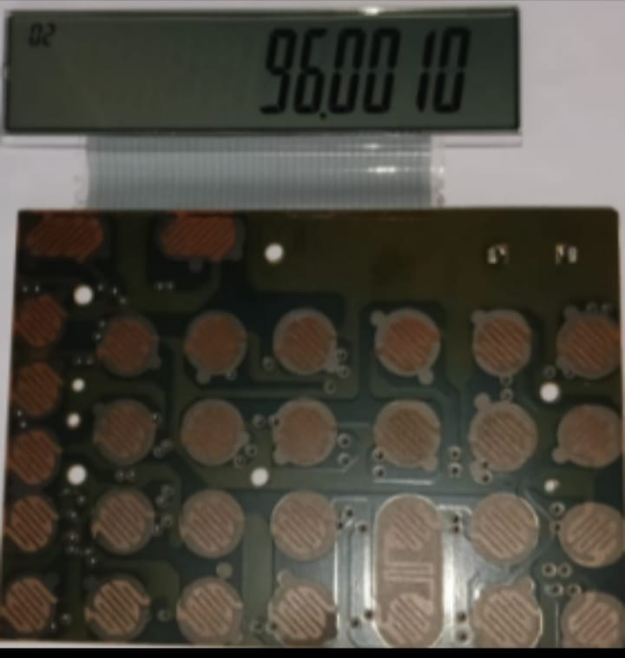

2. Internal Components of a Digital Calculator

2.1 Power Supply Unit
- Provides required DC voltage to all internal circuits.
- Usually powered by a battery or solar cell.
- Ensures stable operation of ICs and display.

2.2 Keypad (Input Unit)
- Consists of numeric keys (0–9) and function keys (+, −, ×, ÷, =, ON, OFF).
- Each key press completes an electrical path.
Generates electrical signals corresponding to user input

2.3 Encoder
- Converts keypad signals into binary or BCD (Binary Coded Decimal) form.
- Ensures compatibility with digital processing circuits.

2.4 Control Unit
- Acts as the brain of the calculator.
- Controls the sequence of operations.
- Decides when data should be stored, processed, or displayed.

2.5 Registers (Memory Unit)
- Temporarily store input numbers.
- Hold intermediate results during calculation.
- Store final output before display.

2.6 Arithmetic Logic Unit (ALU)
- Performs arithmetic operations.
- Receives data from registers.
- Executes operations based on control unit signals.
- Outputs result back to registers.

2.7 Decoder and Display Driver
- Converts binary output into a form suitable for display.
- Controls individual segments of the display.

2.8 Display Unit
- Usually 7-segment LED or LCD display.
- Displays numbers and symbols clearly to the user.

3. Circuit Diagram – Block Level Explanation
Keypad → Encoder → Registers → ALU → Registers → Decoder → Display

Circuit Working Description:
- Power supply energizes all blocks.
- Keypad sends input signals.
- Encoder converts signals to digital codes.
- Control unit manages data flow.
- Registers store operands.
- ALU performs calculations.
- Result is stored and decoded.
- Display shows the output.

4. Working Process of Digital step-by-step Calculator)
- Switch ON the calculator.
- User presses number keys.
- Input signals are encoded into binary.
- Numbers are stored in registers.
- Operation key is pressed (+, −, ×, ÷).
- Control unit activates ALU.
- ALU performs calculation.
- Result is stored in memory.
- Display unit shows the result.

5. Flowchart of Calculator Operation
Start
↓
Power ON
↓
Read Keypad Input
↓
Is input number?
→ Yes → Store in Register
→ No → Identify Operation
↓
Send data to ALU
↓
Perform Arithmetic Operation
↓
Store Result
↓
Display Output
↓
End

6. Advantages
- Fast and accurate calculations
- Easy operation
- Portable and compact
- Low power consumption

7. Applications
- Education
- Banking and accounting
- Engineering calculations
- Daily household use

